|  |  |
| --- | --- |
| **Idea Portal and**  **Query Management** | |
|  |
| Internship Report  CSE-498 |
| Minhaz Uddin Ahmed  Fall semester 2012 |
|  |
|  |
|  |
|  |

Internship Report

Developing an Idea Portal and Query Management Application with ASP.NET for GPIT

Faculty Advisor

**Dr. Shazzad Hosain**

Assistant Professor

Department of Electrical Engineering & Computer Science

Prepared By

Minhaz Uddin Ahmed

ID: 082-575-042



Department of Electrical Engineering & Computer Science, BS CSE Program

North South University

Dhaka

This report is prepared in order to obtain degree of Bachelor Science in Computer Science and Engineering at North South University Dhaka Bangladesh

In Year 2012

**Abstract**

Grameenphone IT Ltd. is the leading fastest growing IT Company in Bangladesh which is a 100% subsidiary company of Grameenphone Ltd (The largest mobile operator company in Bangladesh)As a leading IT company, The company provides end to end solutions for Bank, Financial Institute, FMCG, Pharmaceuticals and Telecom Industry.

At GPIT during my internship (CSE-498) I was involved with Enterprise Solution department’s technology division. I was given a task to design and implement an Idea Portal for commercial department and a Query Management application as an internship task.

**Idea Portal** is a portal for collecting ideas and storing them for better searching and evaluation. The three parts of the project is given below –

* User Part:

1. Log-in / Registration.
2. Submit idea(both form submission and upload option)
3. Check Idea(Recent, Evaluated, Top and Idea in action)
4. See other’s idea Department wise.
5. Idea Gallery.
6. Voting top Idea.

* Evaluator Part:

1. Login.
2. Check Submitted ideas date wise.
3. Select an idea to Evaluate.
4. See Idea Information.

* Admin Part:

1. Login
2. See all Database tables.
3. Set idea’s recent status.( Upcoming, Under review, Launched)
4. Change Access Control( Membership)
5. Export Database table as excel & word format

In **Query Management** application user’s query are managed in a systematic way. The two part of the application are-

User:

Admin:

* Answer the queries.
* Categorize queries.
* Set Query Status
* Submit Query using password.
* Check Query status.
* Check previous Query.

**Declaration**

This is to certify that this project is the outcome of the work of undersigned. No part of this has been submitted elsewhere partly or fully for the award of any degree or diploma. Any material reproduced in this has been properly acknowledged.

……………………………

Minhaz Uddin Ahmed

ID: 082-575-042

B.S. in Computer Science and Engineering

Department of EECS

North South University

**Letter of Transmittal**

I take pleasure in submitting my report on the topic – “The development of an Idea Portal and Query Management application with ASP.NET for GPIT”, which was assigned to me as a task for my Internship at GPIT.

I believe that the knowledge and experience I have gathered while working on the project will immensely help me in my future professional life.

I have concentrated my best effort to achieve the objectives of the study and hope my endeavor will serve the purpose. However I will always be ready to provide any further clarification that you may require.

I would like to request you to accept my report and oblige thereby.

Thanking you,

Minhaz Uddin Ahmed

ID: 082-575-042

Intern and Abstract Approved By:

**…………………………………..**

**Dr. Shazzad Hosain**

**Assistant Professor**

**EECS department**

**North South University Dhaka**

**Date of Approval:…………………..**

……………………………….

**Dr. Kazi M. A. Salam**

**Chairman of EECS Department**

**North South University Dhaka**

**Date of Approval…………….…**

**Acknowledgement**

First of all, I wish to acknowledge the immense grace and profound kindness of the Almighty Allah, the supreme authority of the universal.

I am indebted to all who have directly or indirectly supported me in doing the project and writing the report.

I am thankful and express my gratitude to Dr. Shazzad Hosain (advisor in NSU) who inspired me and guided me throughout the period of internship that enabled me to successful completion of the report.

I am also grate full to Dr. Kazi M. A. Salam, Chairman of EECS Department for giving me valuable advice and suggestion to complete the report in an appropriate manner.

I extend my thanks to Mr. Golam Kibria (supervisor in GPIT), for providing all the necessary facilities in bringing out this project.

Special regards and greatest appreciation in reserved for all the group member of software development team in GPIT, whose honest feedback, ideas and thought helped me navigate through the difficult phases of internship.

Last but not the least I am thankful to my parents who motivated me throughout this internship period. The preparation of this report would not be possible without their moral support.

I am pleased to say that the whole report is just the presentation of the facts that I have found during my internship through different sources and each is the representation of the information obtained and analysis thereof.

I hope that I have manifested my sincere attempt to represent all the information and other thing to the best of ability.

**Table of Content**

Topic Page no

1: Introduction……………………………………………………………………………...8

2: Project Background

2.1 Proposed system……………………………………………………………………….8

2.2 Facilities………………………………………………………………………………..9

2.3 System Content…………………………………………………………………….…..9

2.4 Limitations if any………………………………………………………………….…...9

2.5 Scope…………………………………………………………………………….……10

2.6 Gnat chart………………………………………………………………………….….10

3: Portal Specification

3.1 Portal requirement…………………………….………………………………………11

3.2 System specification: language, web server, web browser…….………………….11-13

3.3 Database server…………………………………………………………………...…...14

4: Design Phase

4.1 User part: Screenshot………………………………………………………………14-19

4.2 Evaluation part: Screenshot …………………………………………………….…20-21

4.3 Admin Part: Screenshot……………………………………………………………21-23

4.4 Server & solution explorer, web.config……………………………………………24-25

5: Query Management

5.1 Application specification and design………………………………………………26-28

5.2 web.config file……………………………………........................................................29

6: Testing: …………………………..…………………………………………………….31

7: Conclusion……………………………………………………………………………...32

References ………………………………………………………………….……………..33

Appendix A: Source code of the project…………………………………………………..34

**1. Introduction**

An idea can change your life which can introduce new revolution in this modern changing world. So without sitting idle we all need to think deeply about our life, study & work and bring out good ideas to make life better.

In an office environment we all work together to attain our desired goal or mission. That includes hard work, patience, devotion, idea, resources, knowledge etc. A simple new intelligent way of thinking can stimulate the working process. It adds new dimension to work flow to attain better outcome and customer satisfaction.

Query is an eternal part of every task. To get better and clear conception we raise query. Then after solving the query we become able to know our task, tool or processes in a better way. That helps us to fulfill the requirement in a systematic way.

So people working in a workplace should not only work harder but also work smarter way. In this way an individual will be able to catch the colorful butterfly of success and glory.

**2. Project Background:**

**2.1 Proposed System**

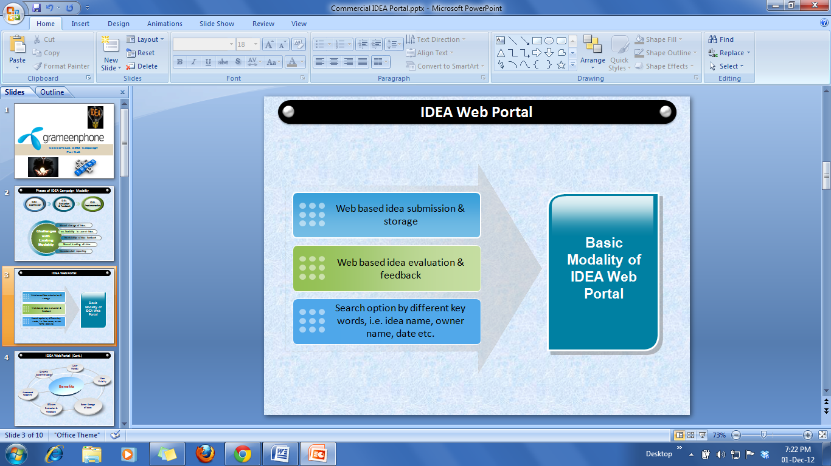

The Idea portal should have a web based idea submission and proper storage management system. Evaluation and feedback should be done online selecting ideas on category basis. During the submission of idea duplicate topic should be checked with message. Database should be secured and some of the tables should have the facility to export data into excel sheet or other format. There should be search option using different keywords like idea name, idea category, idea submission date and etc.

There should be three membership roles. They are- User part, Evaluator part and Admin part. In each part there should a secured access control (login logout) system.

**2.2 Facilities**

1. When employee log-in in my system they see a home page with different Buttons.

2. They (employee) can submit idea, check their idea’s score & recent status and can see others idea related to the category.

3. Password protected.

4. Different search option using key words

5. Report generation and duplicity of idea topic handling.

6. User friendly and more visual.

**2.3. System Content**

1. Privacy protected.
2. One person cant access other’s account.
3. Dynamic search option.
4. More visibility.
5. Efficient evaluation and feedback.

**2.4 Limitation**

1. I am developing prototype application.

2. I am provided with Time constraint which is restricting my work

3. Change of Dot Net version may cause difficulty in debugging

4. Tested in local machine.

**2.5 Scope**

I want to implement my project because this is very important both for the employee and the organization. The company needs its employee to think for the betterment of their company by proposing a new idea of business plan, working process, financial cutoff and many others. My project will help them to submit their valuable thoughts with a few clicks of mouse and keypad. The portal is very user friendly and efficient for collecting and storing ideas.

Query management application will help the user to solve their query in a systematic way. They can also navigate through the previous query by department wise to know more.

**2.6****Gantt chart**

A Gantt chart is a type of bar chart that illustrates a project schedule. Here it illustrates the start and finish dates of the terminal elements of my internship work.

|  |  |  |  |  |  |  |  |  |  |
| --- | --- | --- | --- | --- | --- | --- | --- | --- | --- |
|  | **September** | **September** | **October -November** | **November** | **November -December** | **January-February** | **March** | **April** | **May** |
| **Preparation and planning** |  |  |  |  |  |  |  |  |  |
| **Develop project proposal** |  |  |  |  |  |  |  |  |  |
| **Approve project proposal** |  |  |  |  |  |  |  |  |  |
| **Development of project structure** |  |  |  |  |  |  |  |  |  |
| **Development and test** |  |  |  |  |  |  |  |  |  |
| **Specify detail requirements and submission** |  |  |  |  |  |  |  |  |  |

**3. Project Specifications**

**3.1 Portal requirements:**

There are some requirements of the project. They are-

1. Single sign-on

2. Only for GPIT employees

3. Duplicate check option for ideas in idea submission page

4. Idea submission page - idea title, description, attachment, category

5. Report based on idea category and scoring (descending)

6. Ideas in Action page - Idea search by idea id.

Query management application requirements are-

1. Generate Unique Password

2. Query submit and status checking

3. Previous Query list

**3.2 System Specification:**

For developing the projects I have used ASP.NET version 4 and C# language. For the backend database I used MySql server 2008 and my portal pages consist of different master pages and asp web form pages. As I was suggested by my software development group to do the project using ASP.NET framework which is very useful to implement any web application in Windows platform. As an SDK I used Visual Studio 2010 for developing the web applications.

**Language Description:**

1. **ASP.NET**

ASP.NET is a Web application framework developed and marketed by Microsoft to allow programmers to build dynamic web sites, web applications and web services. It was first released in January 2002 with version 1.0 of the .NET Framework, and is the successor to Microsoft's Active Server Pages (ASP) technology. ASP.NET is built on the Common Language Runtime (CLR), allowing programmers to write ASP.NET code using any supported .NET language.

ASP.NET Web pages, known officially as Web Forms, are the main building block for application development. Web forms are contained in files with an ".aspx" extension; these files typically contain static (X) HTML markup, as well as markup defining server-side Web Controls and User Controls for the Web page. Additionally, dynamic code which runs on the server can be placed in a page within a block <% -- dynamic code -- %>, which is similar to other Web development technologies such as PHP, JSP, and ASP. With ASP.NET Framework 2.0, Microsoft introduced a new code-behind model which allows static text to remain on the .aspx page, while dynamic code remains in an .aspx.vb or .aspx.cs or .aspx.fs file.

1. **HTML**

Hyper Text Markup Language (HTML) is the main markup language for displaying web pages and other information that can be displayed in a web browser. It’s a standardized system for tagging text files to achieve font, color, graphic, and hyperlink effects on World Wide Web pages. HTML is written in the form of HTML elements consisting of tags enclosed in angle brackets (like <html>), within the web page content. HTML tags most commonly come in pairs like <h1> and </h1>, although some tags, known as empty elements, are unpaired, for example <img>. In between these tags web designers can add text, tags, comments and other types of text-based content.The browser does not display the HTML tags, but uses the tags to interpret the content of the page.

HTML elements form the building blocks of all websites. HTML allows images and objects to be embedded and can be used to create interactive forms. It provides a means to create structured documents by denoting structural semantics for text such as headings, paragraphs, lists, links, quotes and other items. It can embed scripts written in languages such as JavaScript which affect the behavior of HTML web pages.

1. **CSS(cascading style sheet)**

Cascading Style Sheets (CSS) is a style sheet language used for describing the presentation semantics (the look and formatting) of a document written in a markup language. It’s most common application is to style web pages written in HTML and XHTML, but the language can also be applied to any kind of XML document, including plain XML, SVG and XUL.

CSS is designed primarily to enable the separation of document content (written in HTML) from document presentation, including elements such as the layout, colors, and fonts. This separation can improve content accessibility, provide more flexibility and control in the specification of presentation characteristics, enable multiple pages to share formatting, and reduce complexity and repetition in the structural content (such as by allowing for table less web design)

1. **C#( C Sharp)**

C#is a multi-paradigm programming language encompassing strong typing, imperative, declarative, functional, generic, object-oriented (class-based), and component-oriented  programming disciplines. It was developed by Microsoft within its .NET initiative and later approved as a standard by Ecma (ECMA-334) and ISO (ISO/IEC 23270:2006). C# is one of the programming languages designed for the Common Language Infrastructure.

C# is intended to be a simple, modern, general-purpose, object-oriented programming language.  Its development team is led by Anders Hejlsberg. The most recent version is C# 5.0, which was released on August 15, 2012.

1. **jQuery**

jQuery is a multi-browser JavaScript library designed to simplify the client-side scripting of HTML. It was released in January 2006 at BarCamp NYC by John Resig. It is currently developed by a team of developers led by Dave Methvin. Used by over 55% of the 10,000 most visited websites, jQuery is the most popular JavaScript library in use today.

jQuery is free, open source software, licensed under the MIT License. jQuery's syntax is designed to make it easier to navigate a document, select DOM elements, create animations, handle events, and develop Ajax applications. jQuery also provides capabilities for developers to create plug-ins on top of the JavaScript library. This enables developers to create abstractions for low-level interaction and animation, advanced effects and high-level, theme-able widgets. The modular approach to the jQuery library allows the creation of powerful dynamic web pages and web applications.

1. **JavaScript**

JavaScript (JS) is an open source client-side scripting language commonly implemented as part of a web browser in order to create enhanced user interfaces and dynamic websites.

JavaScript is prototype-based scripting language that is dynamic, weakly typed and has first-class functions. It uses syntax influenced by the language C. JavaScript copies many names and naming conventions from Java, but the two languages are otherwise unrelated and have very different semantics. The key design principles within JavaScript are taken from the self and Scheme programming languages. It is a multi-paradigm language, supporting object-oriented, imperative, and functional programming styles.

**7. Web browser:**

Internet Explorer, Mozilla Firefox, Opera, Google Chrome

**3.3 Database server:**

**MySQL Server**

MySQL is the world's most used open source relational database management system (RDBMS) as of 2008 that run as a server providing multi-user access to a number of databases.

The MySQL development project has made its source code available under the terms of the GNU General Public License, as well as under a variety of proprietary agreements. MySQL was owned and sponsored by a single for-profit firm, the Swedish company MySQL AB, now owned by Oracle Corporation.

MySQL is a popular choice of database for use in web applications, and is a central component of the widely used LAMP open source web application software stack (and other 'AMP' stacks). LAMP is an acronym for "Linux, Apache, MySQL, Perl/PHP/Python." Free-software-open source projects that require a full-featured database management system often use MySQL.

**4. Design Phases (Idea Portal)**

**4.1 User part**

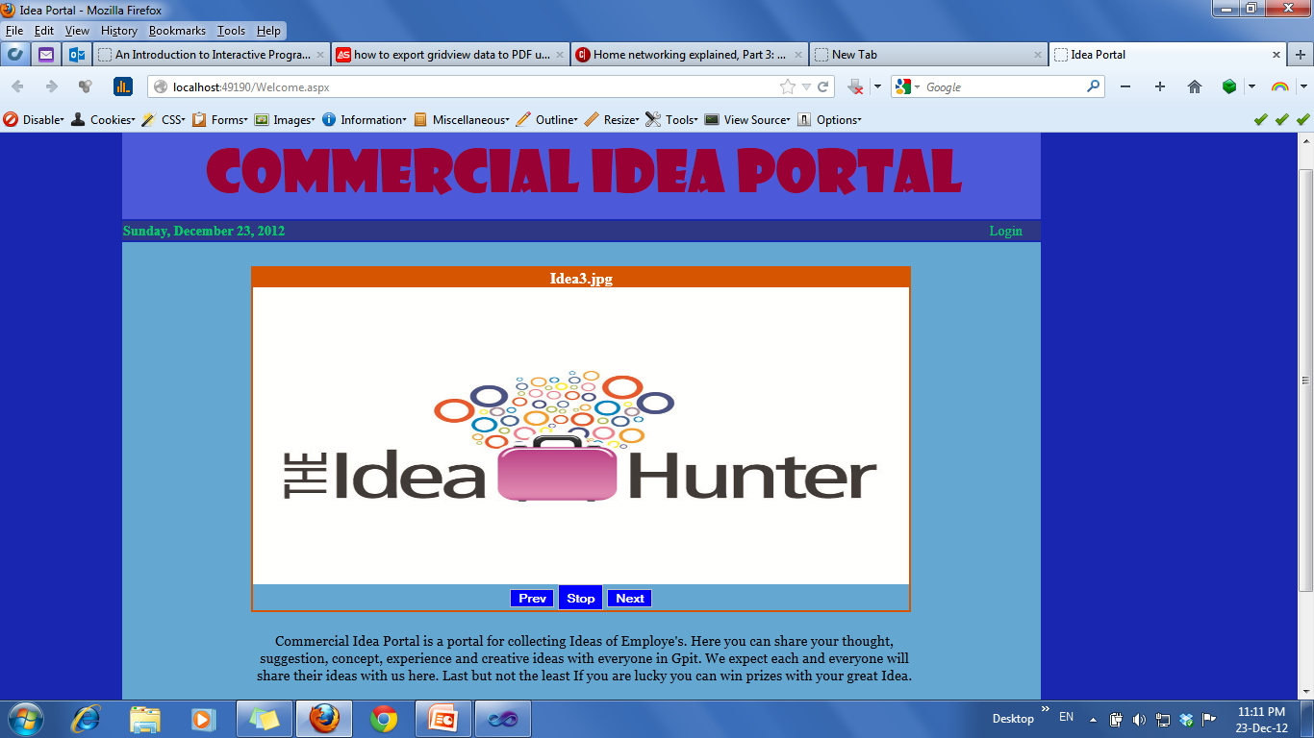

**First page**

Here is the Front page of Idea Portal.User need to login to access the portal content. Login page for the user(employee) is given below-

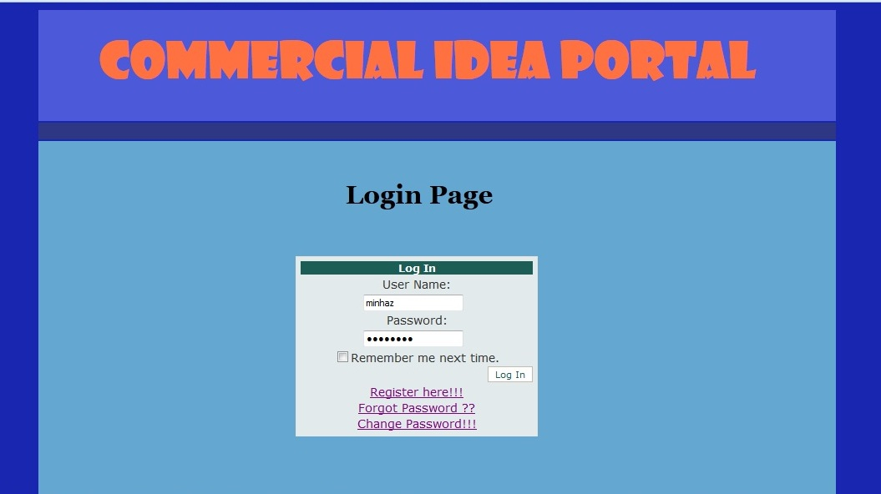

**Login Page**

If user is not registered then he/she need to do Registration by inserting user name and passsword in the register page below with a security question-

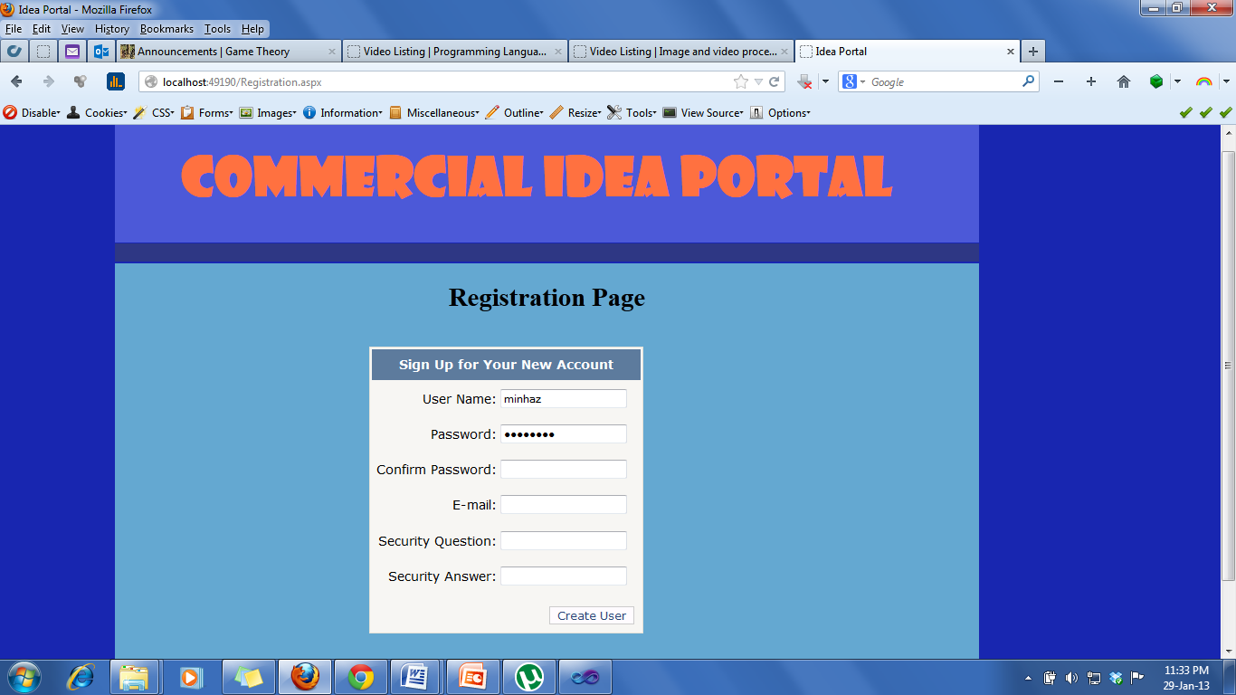

**Registration Page**

In case of forget password he will see the window below**-**

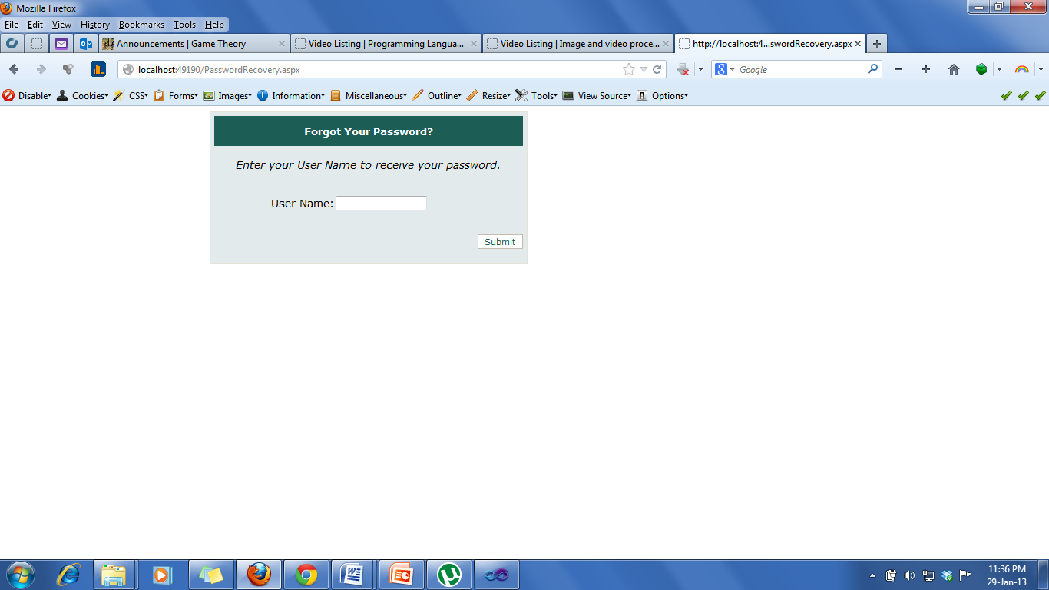

**Forgot password page**

And for changing password user will see the window below-

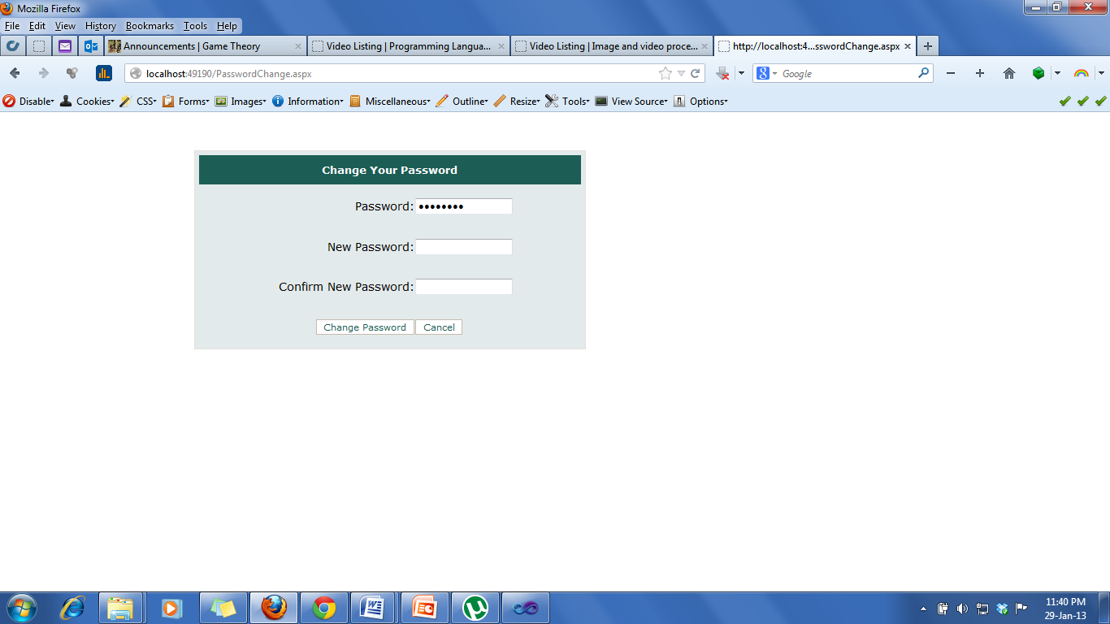

**Changing Password page**

After Logged in User (employee) will see the home page with some options given below-

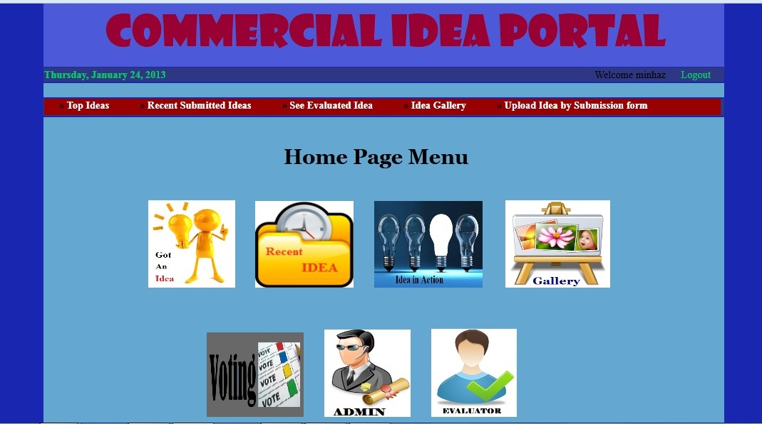

**Home Menu Page**

In the home menu page there are image buttons of idea submition, recent idea, idea in action, idea gallery, voting the best idea and for admin & evaluator there are Admin and Evaluator button.

If the user want to submit idea then he need to click the (submit idea) button. After clicking that he need to fill up a form .the form has validation control with same or existing topic deniel option. After submiting we can see the details submitted below and can go to home page or can see others idea.

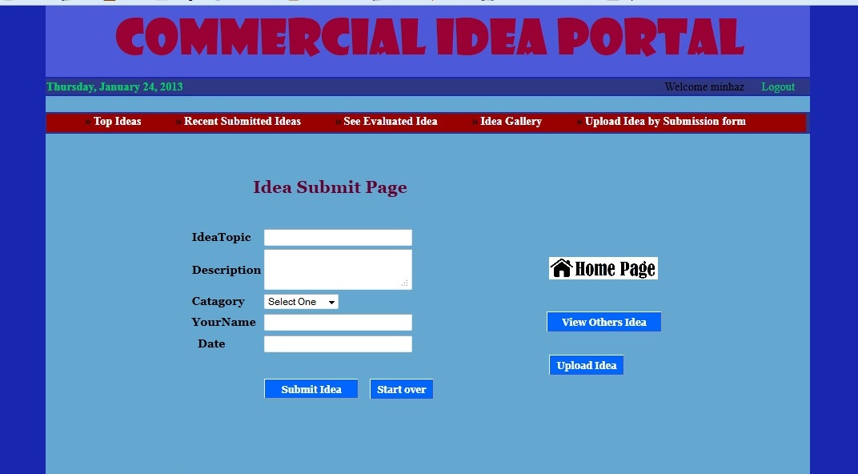

**Idea Submition page**

User has the option to submit Idea by uploading the idea sumbition form page like below. For that processs he need to download the Idea submission form that is given at the top of the grid view. After filling the form with necessary information he need to upload the form here to complete the submission process.

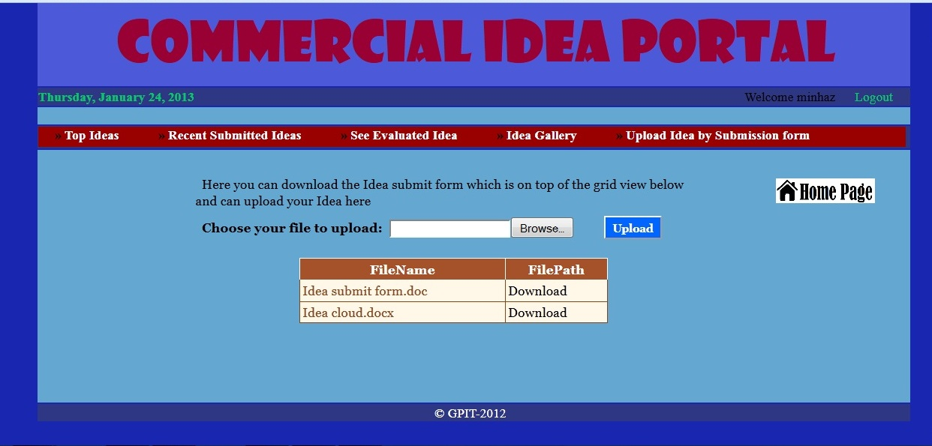

**Upload Idea Page**

Going to homepage user can see the Recent submitted idea, Evaluated Idea , Top idea on basis of mark achieved by the evaluator by selecting the idea category from the drop down list. The category are- P&O ( People and organization), Commercial, CEX (Customer experience), Financial and Technology.The Screenshot of the pages are given below-

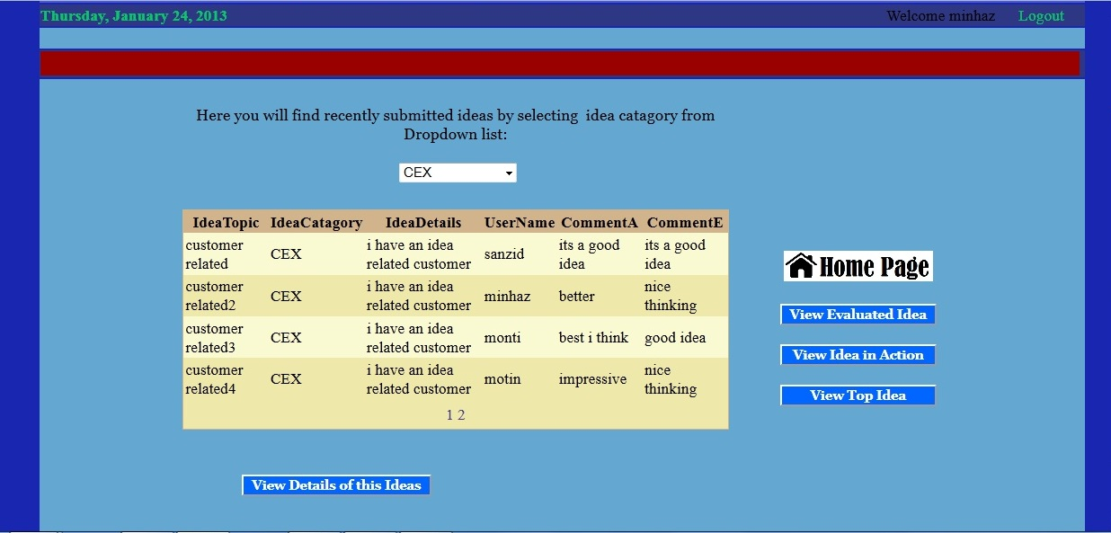

**Recent Idea**

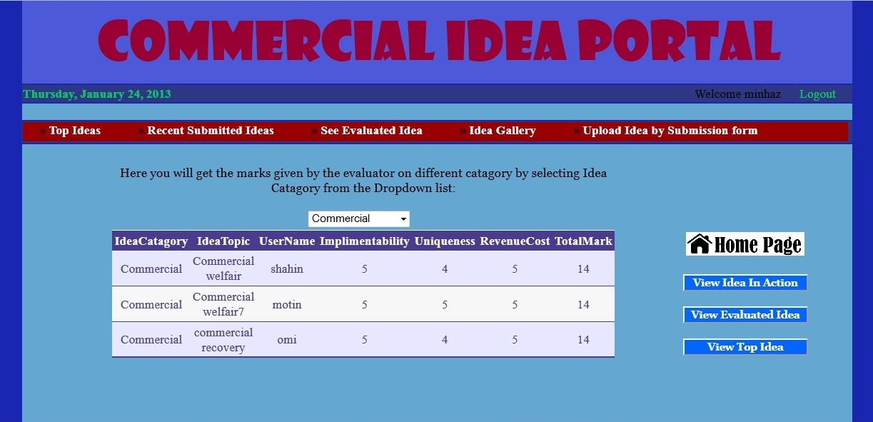

**Evaluated Idea page**

User can also check the Idea status by choosing the status- Comming soon, Reviewed, Under review and launched like below-

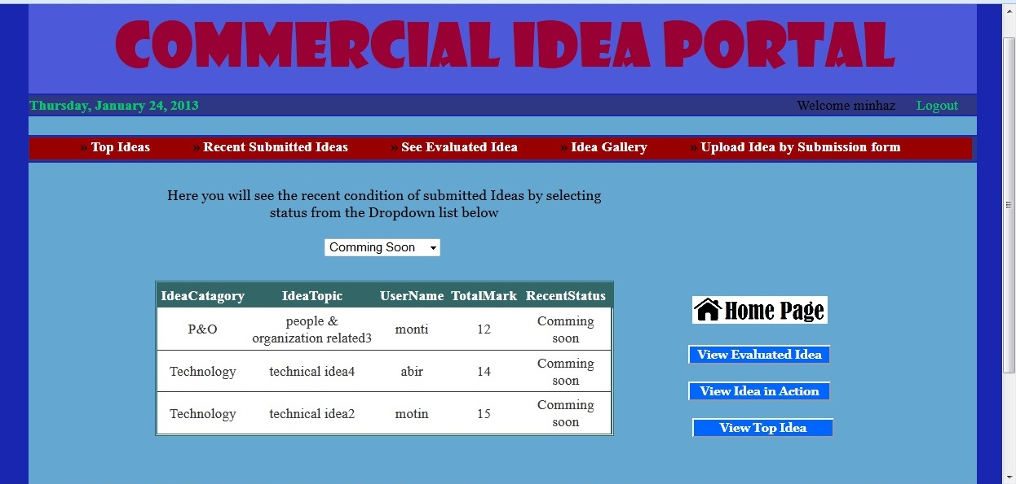

**Idea status**

Then the User can see the gallery pictures and details with fancy zoom out option like this-

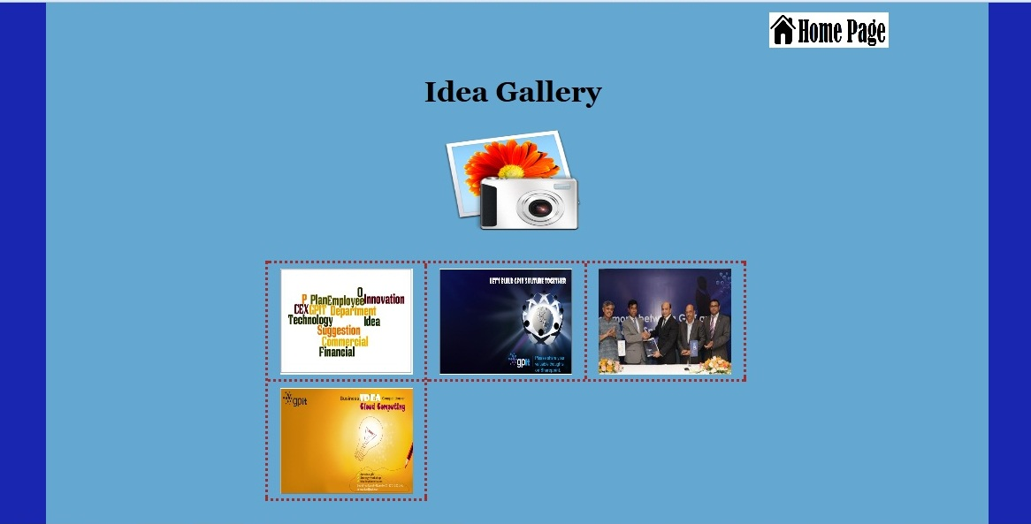

**Photo Gallery Page**

User can also Vote for the top idea in the portal. In this process the admin selectes the top three idea submitter name and user can select one to vote. Then he can see the result of his voting in a table with bar chart which shows everyone voting percentages and who is runnig ahead with greater percentage.

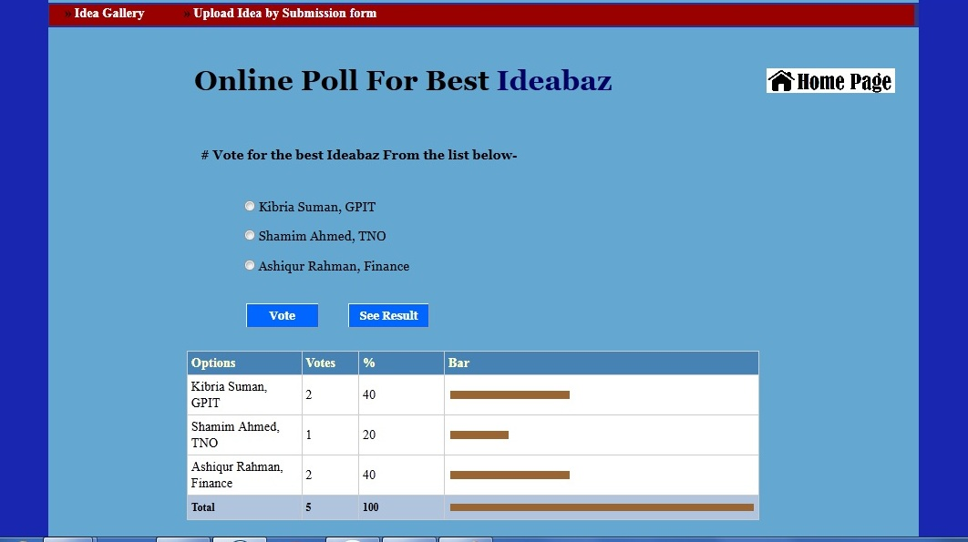

**Voting page**

**4.2 Evaluator Part**

Like user evaluator also need to login. If the user is a evaluator he can access evaluator page otherwise the login page will come to block the access to the page

From home page an evaluator can see all the submittted idea and their status. Then for evaluation he need to click the button called Evaluate Idea. Then he need to select the Ideacatagory from drop down list and select the specif idea from the list to fill up the evaluation form .After clicking insert the data goes to database.

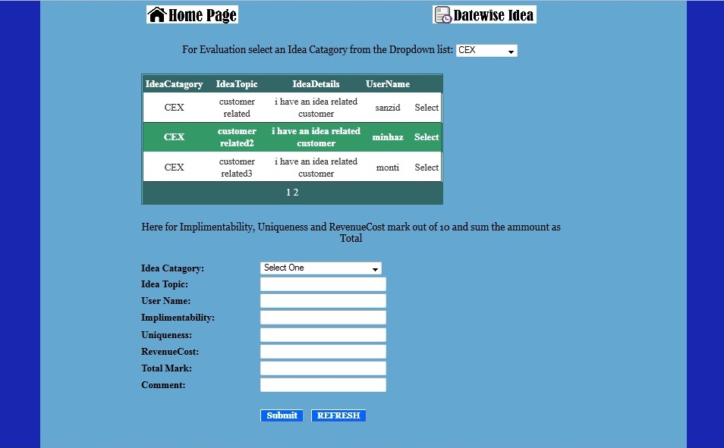

**Evaluation page**

An Evaluator can also check the Submited idea by date wise like below-

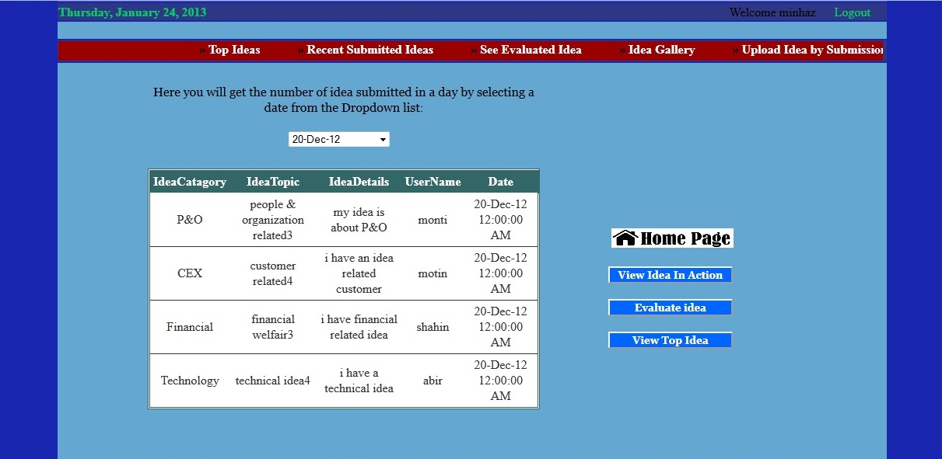

**Date wise Submitted Idea**

**4.3 Admin part**

Admin also need to login. If the user is Admin he can access Admin page otherwise the login page will come to block the access to the page.Here is the Admin home page-

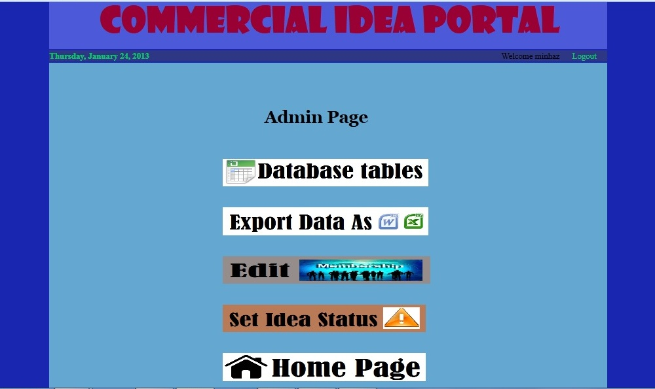

**Admin menu**

An admin has the option to export database table to Excel and word format like below-

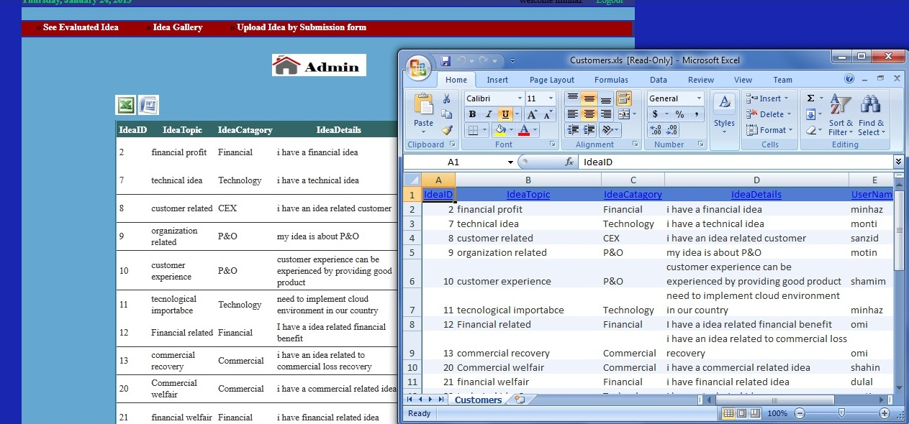

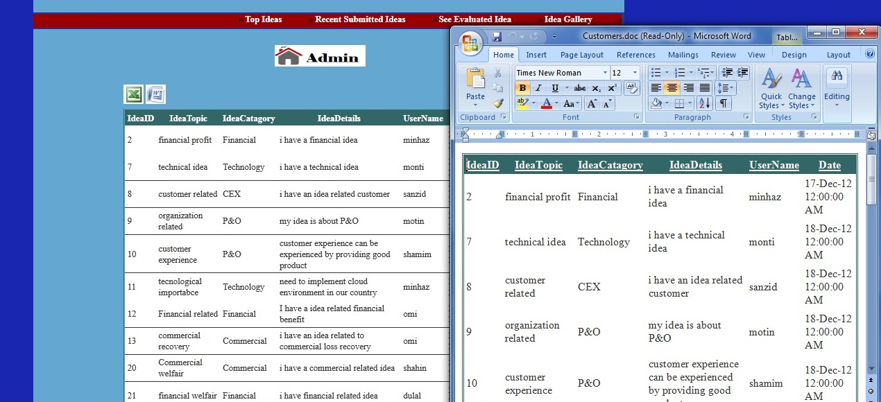

**Export Table as Word And Excel**

Admin can change the Access control and can change the idea status means whether the idea is reviewed or implimented or not like beow-

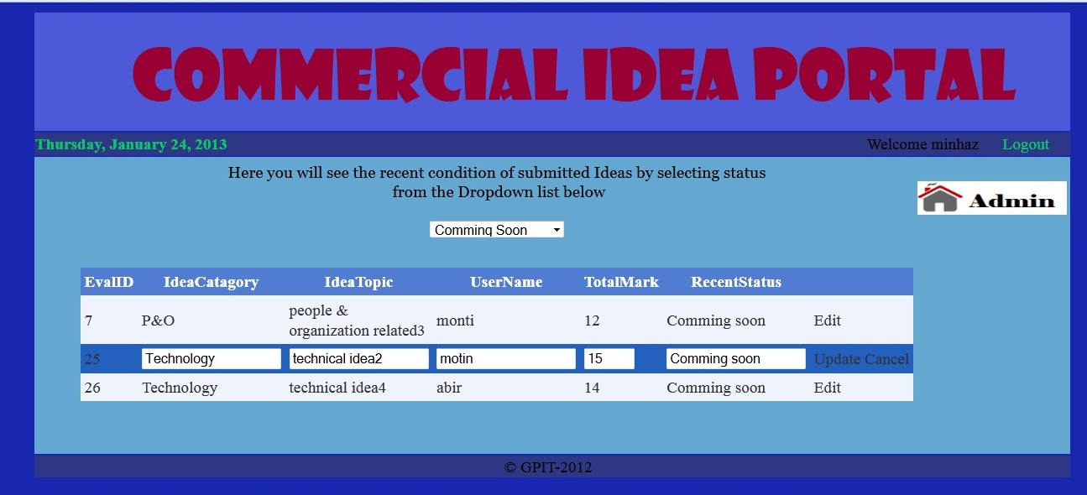

**Change Idea Status**

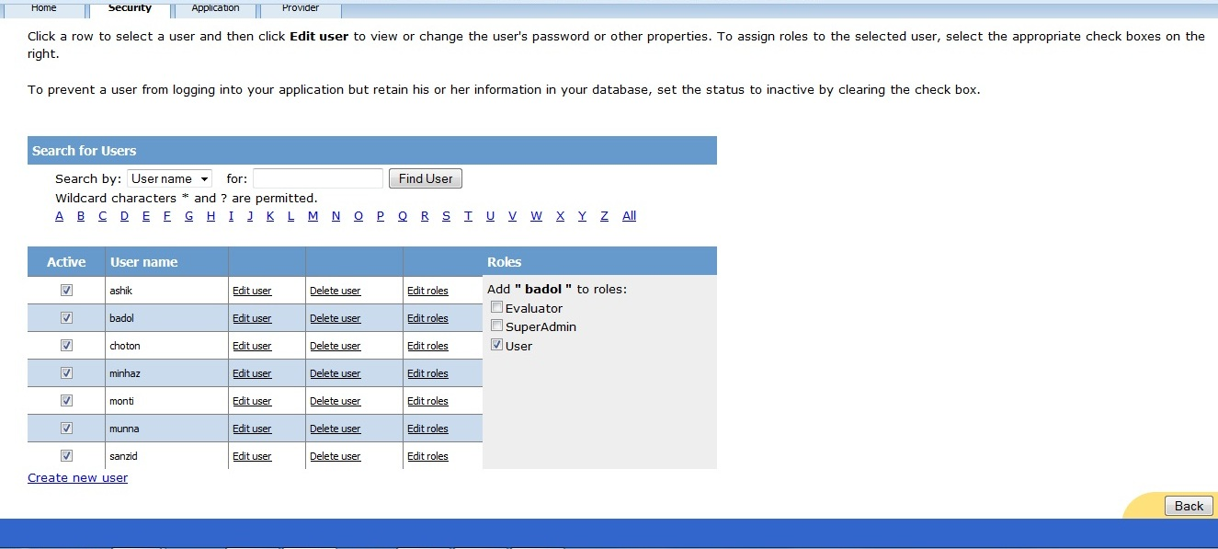

**Change Access control ( Role )**

Admin can also see all the database table and can edit those-

In Visual Studio the server explorer and solution explorer are shown below. Here right side in Solution explorer we can see the form pages (extention .aspx), their backend pages (extention .aspx.cs), referances, masterpages, image folders, app_code, app_data and properties option.

Left side in server explorer we can see all the database related things like table names,database name and different folders.

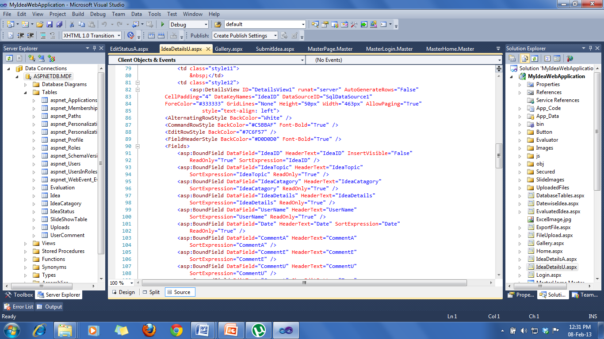

**Server Explorer Solution Explorer**

Here in the UML Database diagram we can see the relation between the database tables of the Idea portal. The tables are connected with different primary key and foreign key.

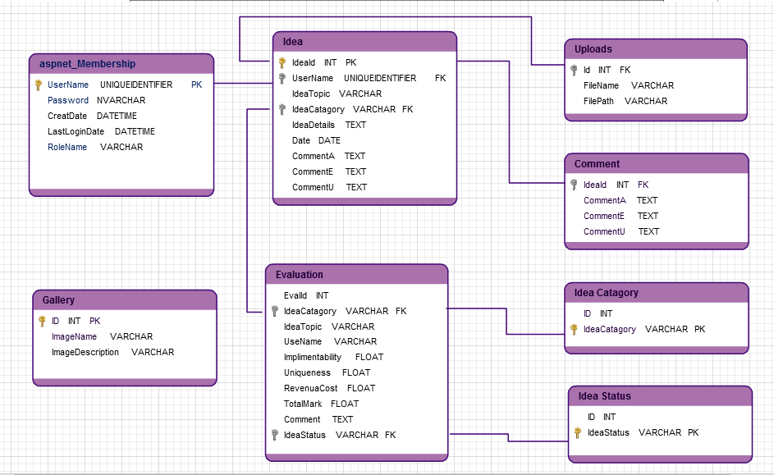

**Idea Portal UML Database Diagram**

**web.config files of Idea Portal**

<?xml version="1.0"?>

<!--

For more information on how to configure your ASP.NET application, please visit

http://go.microsoft.com/fwlink/?LinkId=169433

-->

<configuration>

<connectionStrings>

<add name="ASPNETDBConnectionString1" connectionString="Data Source=.\SQLEXPRESS;AttachDbFilename=|DataDirectory|\ASPNETDB.MDF;Integrated Security=True;User Instance=True"

providerName="System.Data.SqlClient" />

</connectionStrings>

<system.web>

<authentication mode="Forms" />

<roleManager enabled="true" />

<compilation debug="true" targetFramework="4.0" />

</system.web>

</configuration>

**5. Query Management Application**

**5.1Application specification and Design**

In Query management application, user need to login to submit query with a generated password. Then user can check his query status by inserting the password that was used for query submission. User can also see the previous query by Department wise.

Use case diagram of Query management application is given below. Here we can see two roles- user and admin.

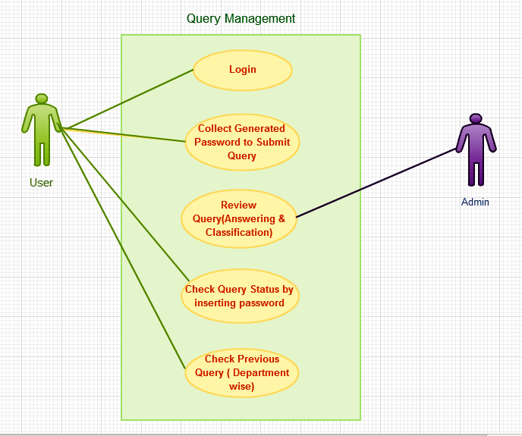

**Use case diagram of Query Management**

In the home page of the application there are three image buttons of post query, check query status and previous query. User need to collect password by clicking Generate password to submit query.

In the next page we can see the Homepage and query submission page picture-

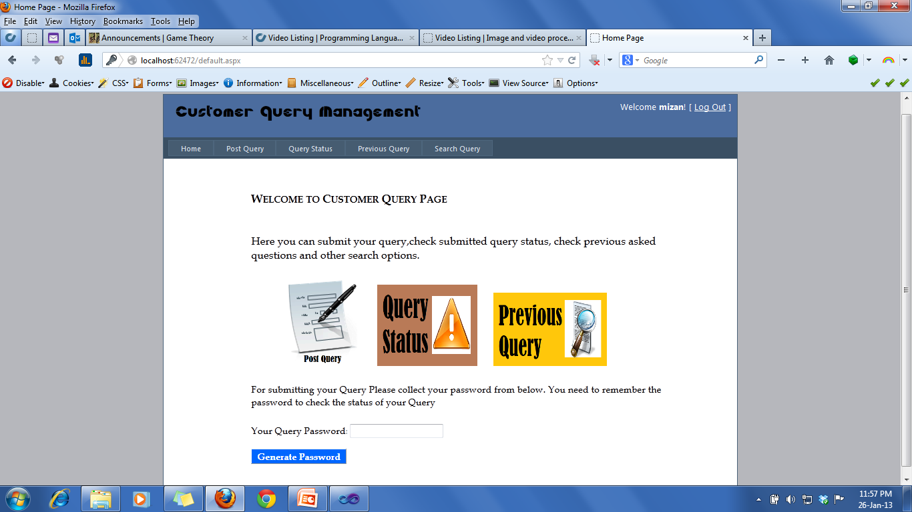

**Home page**

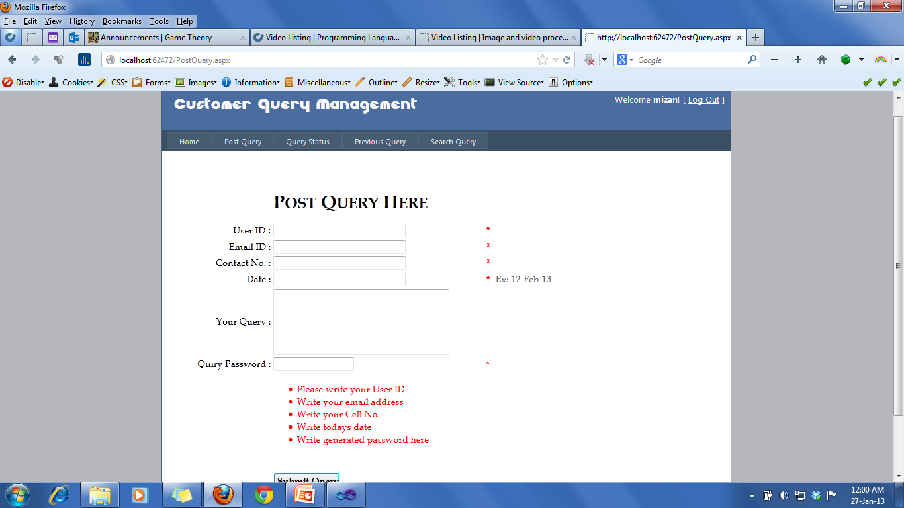

**Query Submission form page**

User can check query status by inserting his password and can check previous Query record by selecting departments in the drop down list. The departments’ are- law, finance, management, accounts and maintenance.

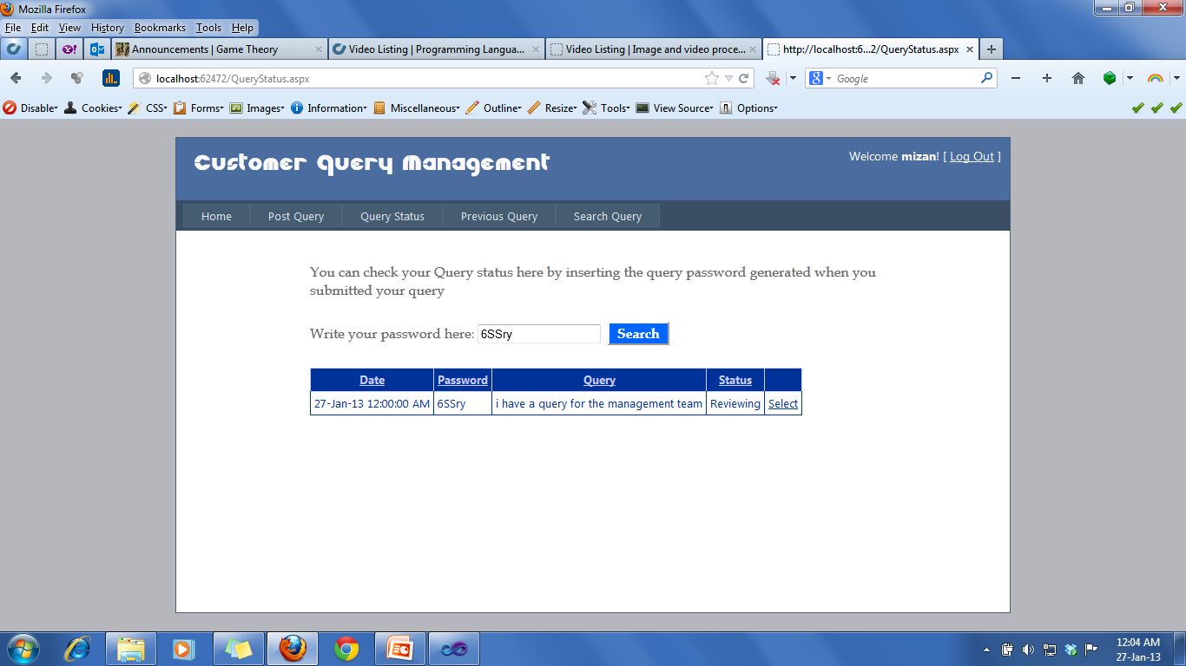

**Query Status Checking**

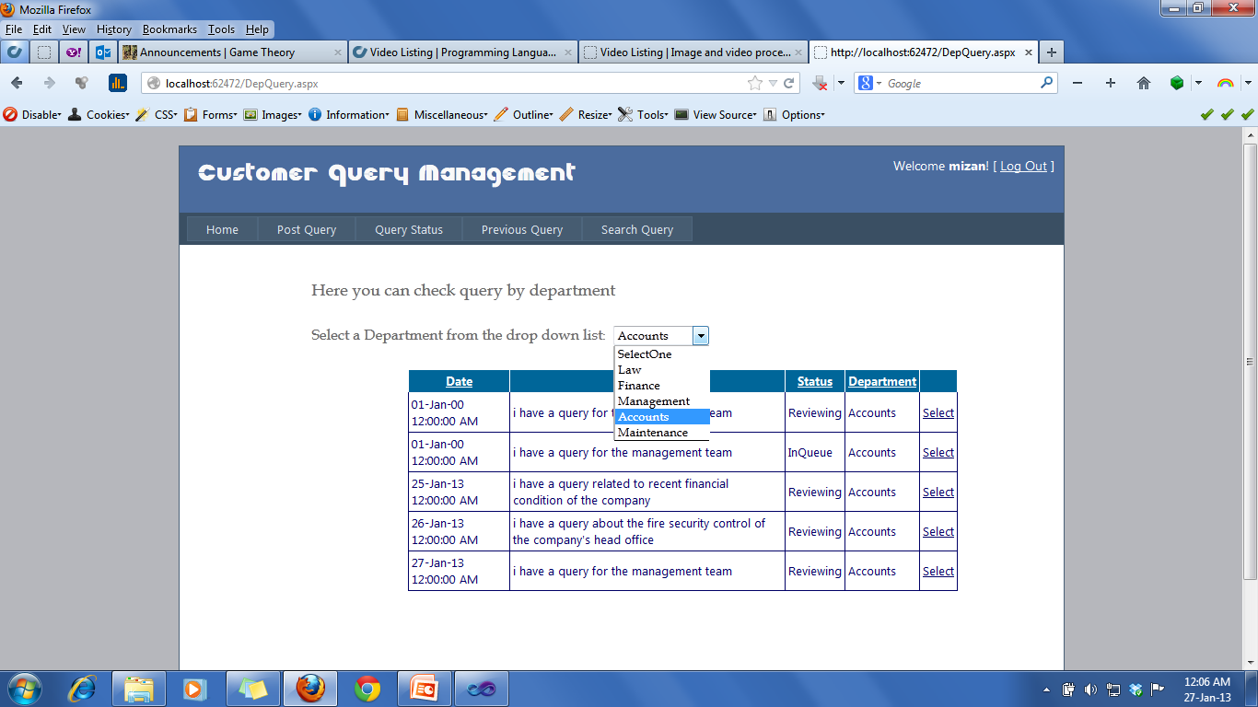

**Checking Previous Query**

In the UML Database diagram in the next page we can see the relation between the database tables which are connected using foreign key and primary key-

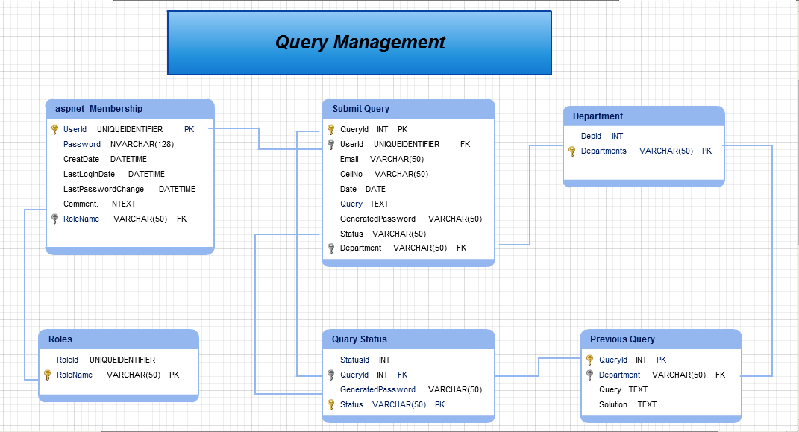

**UML Database diagram**

5.2 Web.config files of Query management application-

<?xml version="1.0"?>

<!--

For more information on how to configure your ASP.NET application, please visit

http://go.microsoft.com/fwlink/?LinkId=169433

-->

<configuration>

<connectionStrings>

<add name="ApplicationServices" connectionString="data source=.\SQLEXPRESS;Integrated Security=SSPI;AttachDBFilename=|DataDirectory|\aspnetdb.mdf;User Instance=true"

providerName="System.Data.SqlClient" />

<add name="ASPNETDBConnectionString1" connectionString="Data Source=.\SQLEXPRESS;AttachDbFilename=|DataDirectory|\ASPNETDB.MDF;Integrated Security=True;User Instance=True"

providerName="System.Data.SqlClient" />

</connectionStrings>

<system.web>

<compilation debug="true" targetFramework="4.0" />

<authentication mode="Forms">

<forms loginUrl="~/Account/Login.aspx" timeout="2880" />

</authentication>

<membership>

<providers>

<clear/>

<add name="AspNetSqlMembershipProvider" type="System.Web.Security.SqlMembershipProvider" connectionStringName="ApplicationServices"

enablePasswordRetrieval="false" enablePasswordReset="true" requiresQuestionAndAnswer="false" requiresUniqueEmail="false"

maxInvalidPasswordAttempts="5" minRequiredPasswordLength="6" minRequiredNonalphanumericCharacters="0" passwordAttemptWindow="10"

applicationName="/" />

</providers>

</membership>

<profile>

<providers>

<clear/>

<add name="AspNetSqlProfileProvider" type="System.Web.Profile.SqlProfileProvider" connectionStringName="ApplicationServices" applicationName="/"/>

</providers>

</profile>

<roleManager enabled="true">

<providers>

<clear />

<add connectionStringName="ApplicationServices" applicationName="/"

name="AspNetSqlRoleProvider" type="System.Web.Security.SqlRoleProvider" />

<add applicationName="/" name="AspNetWindowsTokenRoleProvider"

type="System.Web.Security.WindowsTokenRoleProvider" />

</providers>

</roleManager>

</system.web>

<system.webServer>

<modules runAllManagedModulesForAllRequests="true"/>

</system.webServer>

</configuration>

**6. Testing/verification**

I had a great experience while testing and verification of the portal. During the last phase some more features were added. Then the portal was uploaded to the server for testing purpose. During that time some database connectivity complication came up and was solved there by.

The log file of Idea portal is given below-

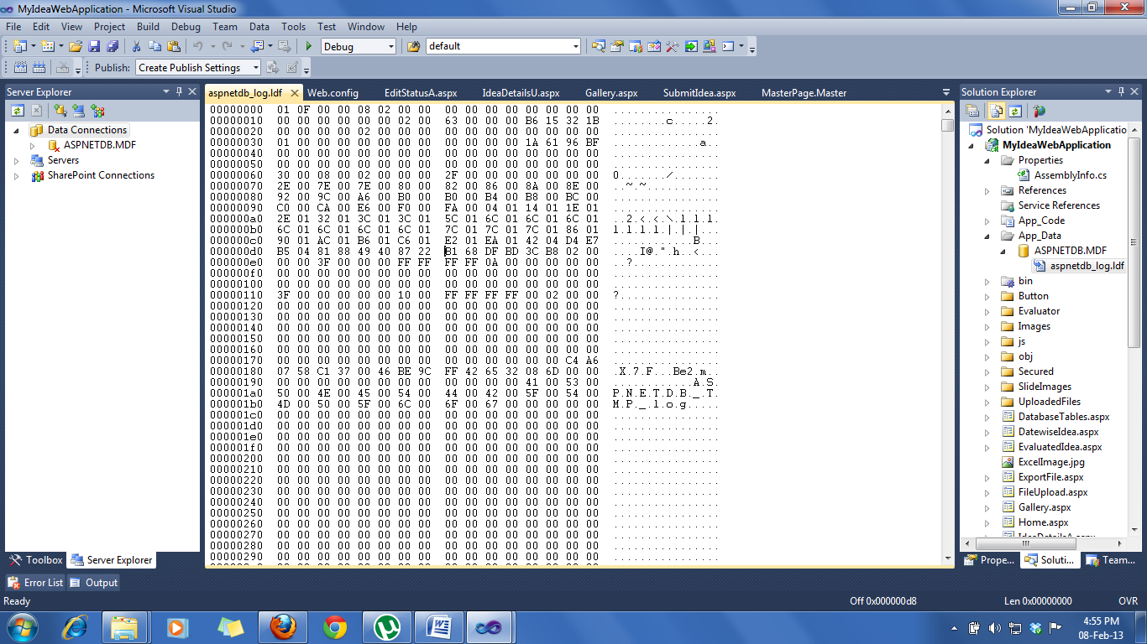

The log file of Query management is given below-

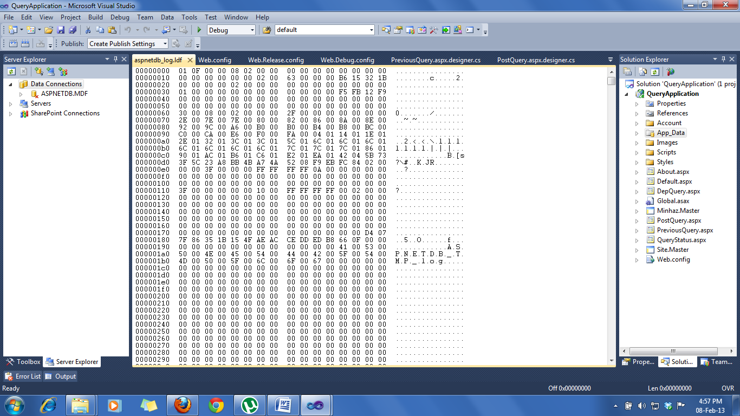

**7. Conclusion**

It is indeed a challenging task to work in a top software company like GPIT with a very dynamic software development team. The software developer role function requires candidate to develop code using programming specification, high level design documentation and implement the identified component based on client requirements. Software developer also ensures that the implemented application or software are unit tested and ready to be intrigued into a product, provide defect fixes identified by the verification team during the software development life cycle and be exposed to project across different domains.

This project gave me the chance to learn and grow in corporate world. It helped me to learn how to deliver a quality work in fixed time and limited resources in a given time period also learned a lot about team work and time management. And how to become a independent thinker. The internship gave a motivation to pursue software engineering more and to understand all the models required to successfully manage a complicated project. So I would say it made a really big impact in my carrier.

I hereby encourage the entire engineering student to pursue an internship program. It provides an opportunity to experience a real world work experience, and it has allowed us to apply our knowledge to real, complex and challenging problems.

**Reference**

[1] Microsoft Asp. Net website: <http://www.asp.net/web-forms/tutorials>

[2] C Sharp-2010 All In One for Dummies by Bill Sempf, Stephen R. Davis, Charles Sphar.

[3] For different icon and logo: <http://www.iconfinder.com/>

[4] For gallery and slider: <http://www.aspdotnet-suresh.com/>

[5] For details: <http://en.wikipedia.org/>

**Appendix A: Source Code**